**Jenkins**

**What is Jenkins?**

Jenkins is an open-source automation tool is created using Java programming language. For the initial setup, it facilitates users with CI/CD (continuous integration (CI) or continuous delivery) technique that simplifies the use and management of processes.

This figure represents the complete flow: from the build to the test a job or a pipeline.

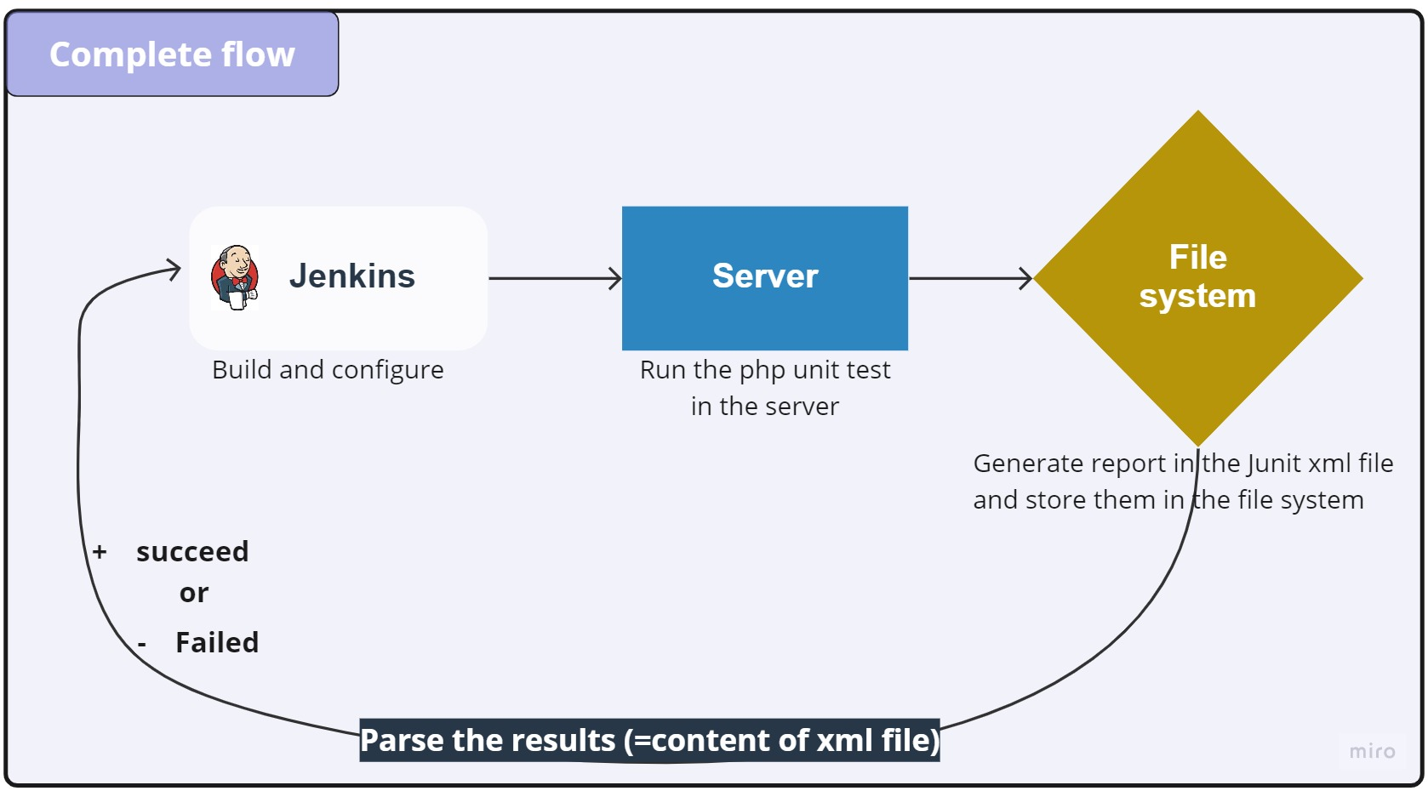

**Jenkins plugins:**

Jenkins plugins work by creating or extending an extension point, which hooks into a specific part of the build process.

The plugins configuration is usually stored in the form of an XML file located inside the $JENKINS_HOME root, which defines the structure and settings that are mandatory for each plugin.

A new Jenkins item can be a job or a pipeline, so we can create project that can Jenkins build for us.

We have two kinds of pipelines: declarative pipeline and scripted pipeline.

**Difference between declarative pipelines and scripted pipelines:**

|  |  |
| --- | --- |
| Declarative pipelines | Scripted pipelines |
| Declarative pipelines always start with the word pipeline.  Example: | Scripted pipelines, on the other hand, always start with the word node.  Example: |

**Installation of Jenkins on Debian:**

Jenkins is a Java-based tool so Java must be installed in your system. If not installed, you can install it using the following command:

**Step 1: Install java**

$ apt-get install default-jre gnupg2 apt-transport-https wget -y

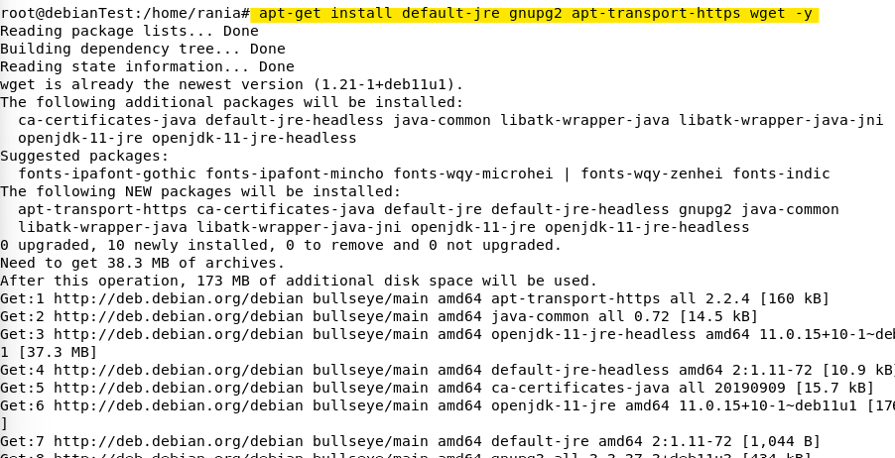

Once the Java is installed, verify the Java version using the following command:

$java -version



**Step 2: Add Jenkins PPA**

First, download and add the GPG key, Next add the Jenkins PPA with the following command:

$ wget <https://pkg.jenkins.io/debian-stable/jenkins.io.key>

$ apt-key add jenkins.io.key

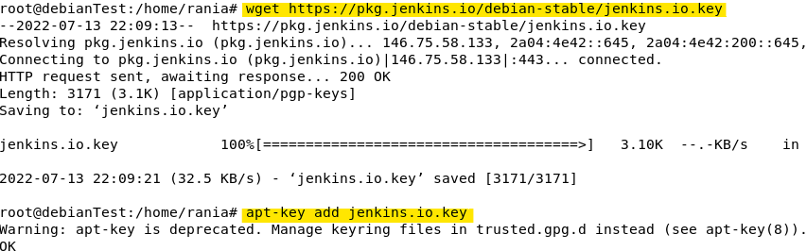

**Step 3: Install Jenkins on Debian**

Once Jenkins PPA has been added, you can update the repository cache with the following command:

$ apt-get update -y

Next, install the Jenkins with the following command:

$ apt-get install jenkins -y

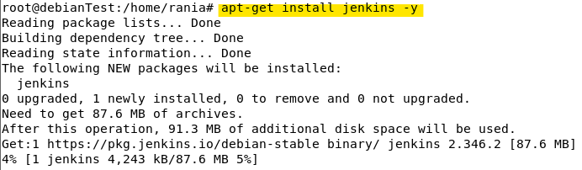

After the installation, verify the Jenkins status using this command :

**$** systemctl status jenkins

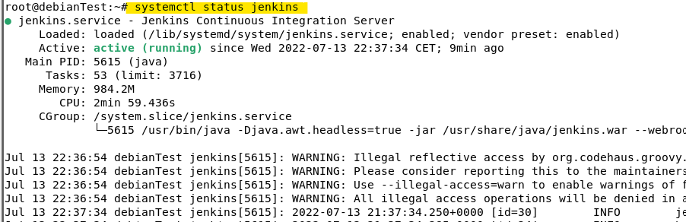

By default, Jenkins listens on port 8080. You can check it with the following command :

ss -antpl | grep 8080 ss -antpl | grep 8080



**Step 4: Access Jenkins Web UI**

To access the Jenkins web interface, open your web browser and type the URL http://your-server-ip:8080. You should see the following page:

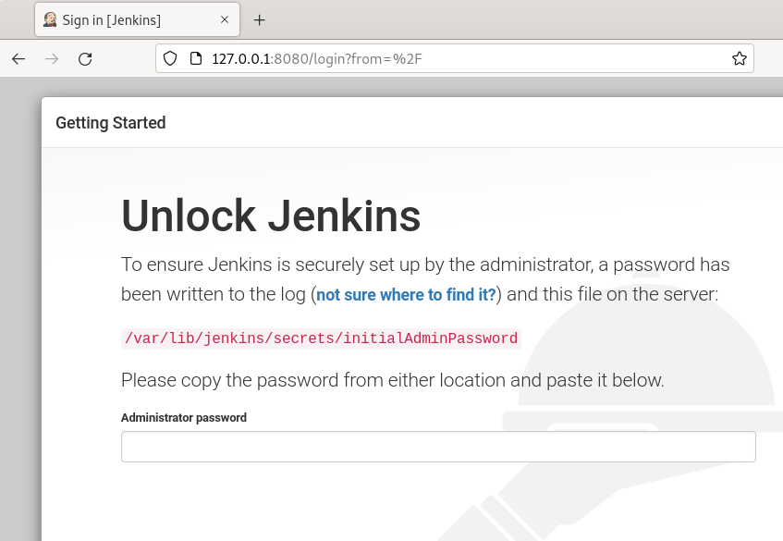

And after installing suggested plugins and creating the admin user this folowing page appear : represente jenkins dashboard

WEBOGRAPHY:

https://www.howtoforge.com/how-to-install-jenkins-on-debian-11/